**FACTORIAL OF A GIVEN NUMBER:**

**EXP NO:09**

**AIM:**To find the factorial of a given number using an 8085 microprocessor.

**APPARATUS:** GNUSim8085

**ALGORITHM:**

1) Load the data into register B  
2) To start multiplication set D to 01H  
3) Jump to step 7  
4) Decrements B to multiply the previous number  
5) Jump to step 3 till the value of B>0  
6) Take the memory pointer to the next location and store the result  
7) Load E with contents of B and clear accumulator  
8) Repeatedly add contents of D to accumulator E times  
9) Store accumulator content to D  
10) Go to step 4

**PROGRAM:**

LDA 2001  
MOV B, A  
MVI C,01H  
MVI E,01H  
LOOP: MOV D, C  
MVI A,00H  
LP: ADD E  
DCR D  
JNZ LP  
MOV E, A  
INR C  
DCR B  
JNZ LOOP  
MOV A, E  
STA 2010  
HLT

**INPUT:**

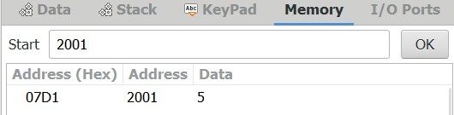

**OUTPUT:**

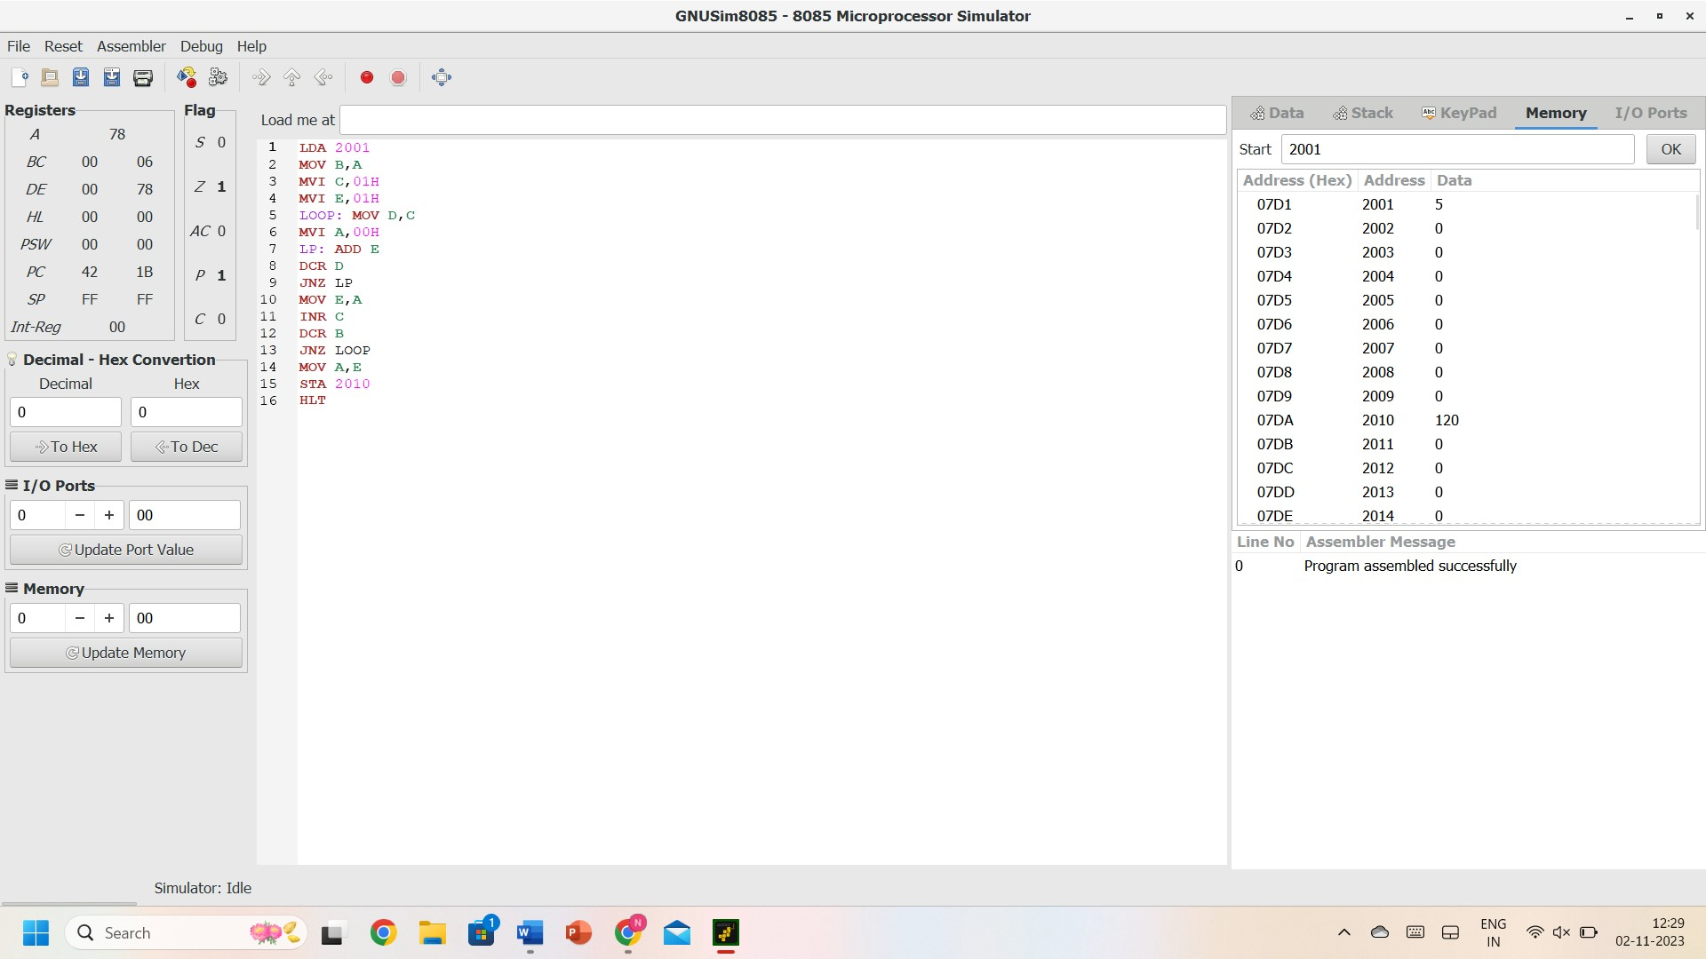

**RESULT:** Thus, the program was executed successfully using 8085 processor simulators.